Project Design Phase-I
Problem – Solution Fit Template

Date | 20 February 2026
Team ID | LTVIP2026TMIDS66673
Project Name | Plugging into the Future: An Exploration of Electricity Consumption Patterns Using Tableau
Maximum Marks | 2 Marks

Problem – Solution Fit Template:
The Problem-Solution Fit simply means that you have found a problem with your customer and that the solution you have realized for it actually solves the customer’s problem. It helps entrepreneurs, marketers and corporate innovators identify behavioral patterns and recognize what would work and why
Purpose:
- To solve complex electricity consumption analysis problems in a way that aligns with the needs of utility companies, policymakers, and consumers.
- To improve adoption of data-driven decision-making by using familiar and effective visualization tools like Tableau dashboards.
- To enhance communication and reporting of electricity usage trends through clear, interactive, and visual insights.
- To increase engagement and trust by addressing frequent challenges such as peak demand management, inefficient energy usage, and lack of transparency in consumption patterns.
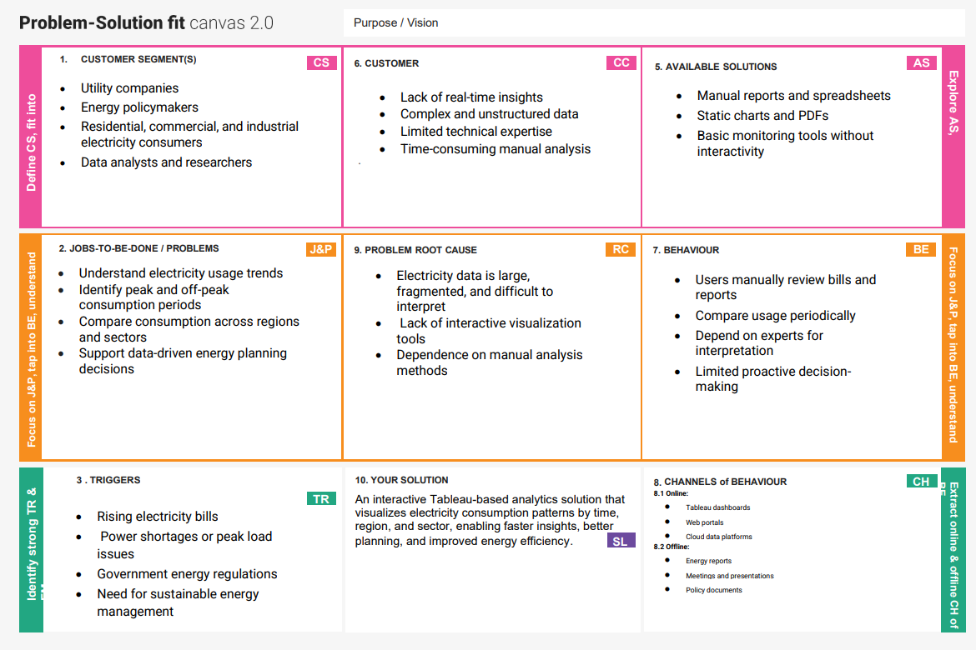
References:
- https://www.ideahackers.network/problem-solution-fit-canvas/
- https://medium.com/@epicantus/problem-solution-fit-canvas-aa3dd59cb4fe

